**Project Report**

Introduction:

**1.1 overview**

A liver patient analysis typically involves a thorough assessment of the liver's structure, function, and overall health. This can include a variety of diagnostic tests and procedures, such as blood tests to evaluate liver enzymes and other liver function markers, imaging studies like ultrasound or MRI, liver biopsy, and other tests to check for specific liver conditions such as hepatitis or cirrhosis.

In addition to these tests, a liver patient analysis may also involve a comprehensive medical history and physical examination, as well as a discussion of any symptoms or concerns the patient may have. Based on the results of these tests and evaluations, healthcare providers can develop a tailored treatment plan that addresses the patient's specific liver health needs, which may include medications, lifestyle changes, and/or other interventions to manage symptoms and prevent further liver damage.

**1.2 Purpose**

Liver patient prediction models can be used in a variety of healthcare settings to help identify patients who may be at risk of developing liver disease or experiencing complications related to liver function. These models typically use a combination of patient demographic data, medical history, and laboratory values to assess a patient's risk profile and predict the likelihood of developing liver-related problems.

By using liver patient prediction models, healthcare providers can potentially identify at-risk patients earlier and intervene with preventative measures or earlier treatment options to prevent or manage liver disease. These models can also help providers prioritize patients for further diagnostic testing or monitoring, and potentially reduce unnecessary healthcare costs by identifying patients who may not require additional testing or interventions.

Overall, liver patient prediction models have the potential to improve patient outcomes by enabling earlier detection and management of liver disease, and reducing the burden of liver-related complications and healthcare costs.

2 Problem Definition & Design Thinking:

2.1 Empathy Map

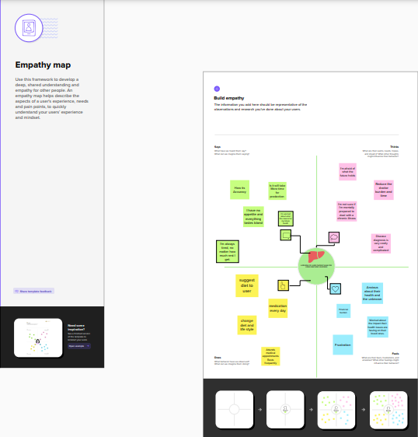

2.2 Ideation & Brainstorming Map

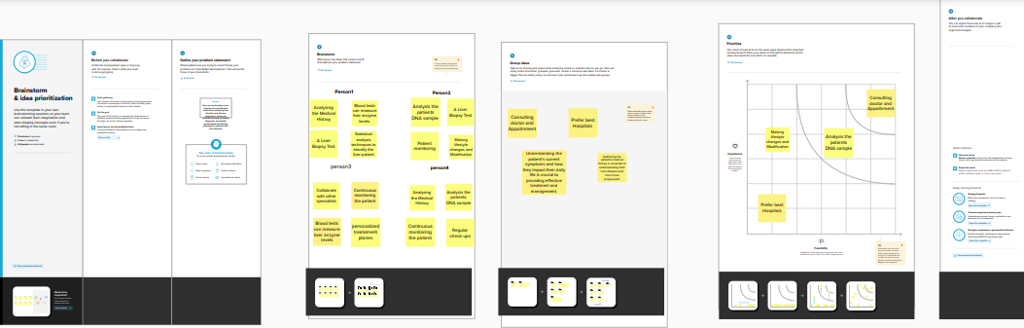

3 RESULT

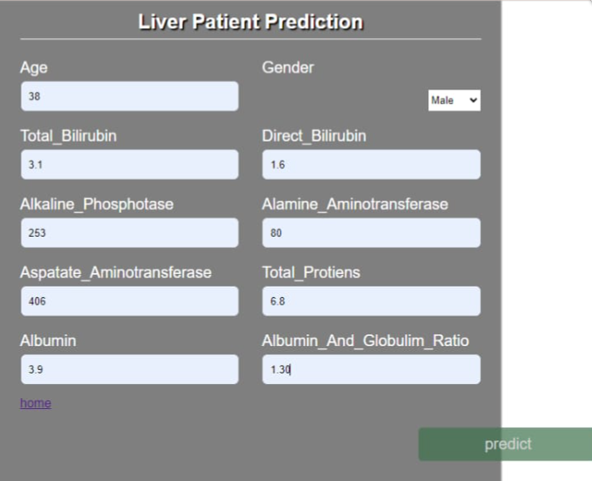

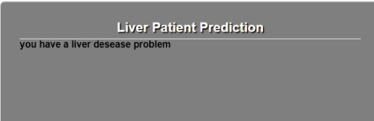

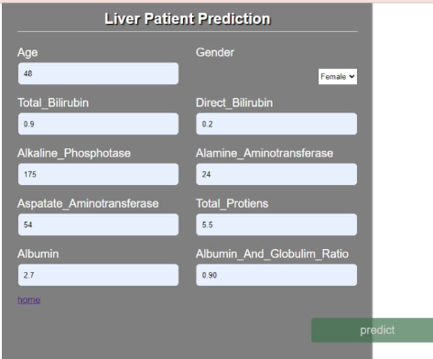

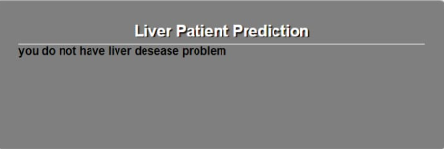

4 ADVANTAGES & DISADVANTAGES

Advantages :

1. Early Detection: Early detection of liver disease is critical for effective treatment. Machine learning can help in identifying patients who are at risk of developing liver disease at an early stage.
2. Cost-effective: Machine learning algorithms can help healthcare providers reduce costs associated with liver disease management. This is because they can identify potential liver disease patients before the disease becomes severe, making it easier to treat and manage.
3. Personalized Treatment: Machine learning algorithms can help doctors develop personalized treatment plans for liver disease patients, based on their unique medical history and lifestyle factors.
4. Data-driven decision making: Machine learning algorithms can help doctors make data-driven decisions, enabling them to predict the likelihood of liver disease in a patient and the possible outcomes of different treatment options.
5. Real-time monitoring: Machine learning can provide real-time monitoring of liver function, helping doctors track disease progression and adjust treatment plans accordingly.
6. Improved Patient Outcomes: Machine learning can help improve patient outcomes by enabling early detection of liver disease, personalized treatment plans, and real-time monitoring. This can lead to improved quality of life for liver disease patients.

Disadvantages:

1. Limited Data: Machine learning algorithms require large amounts of data to produce accurate predictions. In some cases, there may not be enough data available to produce reliable predictions.
2. Overfitting: Overfitting occurs when machine learning algorithms become too specialized in the training data and do not generalize well to new data. This can lead to inaccurate predictions when the algorithm is applied to new patient data.
3. Lack of Transparency: Machine learning algorithms can be complex, and it can be challenging to understand how they arrive at their predictions. This lack of transparency can make it difficult for healthcare providers to explain the rationale behind treatment decisions to patients.
4. Bias: Machine learning algorithms can be biased based on the data they are trained on, which can result in inaccurate predictions for certain patient groups.
5. Integration Issues: Integrating machine learning algorithms into existing healthcare systems can be challenging, and there may be technical difficulties in implementing these systems.
6. Data Privacy and Security: Machine learning algorithms require large amounts of patient data to be effective, which can raise concerns about privacy and security.

5. APPLICATIONS

Liver patient prediction using machine learning can be a valuable tool for early detection and treatment of liver diseases. Machine learning models can analyze large amounts of patient data and identify patterns that may be difficult for humans to detect. By training on relevant features such as age, gender, body mass index, blood test results, and medical history, machine learning algorithms can predict the likelihood of a patient developing liver diseases with high accuracy.

This can aid medical professionals in making informed decisions about patient care, including early intervention and lifestyle changes that can help prevent or manage liver diseases. However, it's important to note that machine learning models are not a substitute for medical diagnosis and treatment. They are only one tool that can aid medical professionals in providing personalized care to patients.

In summary, liver patient prediction using machine learning has the potential to improve patient outcomes and reduce healthcare costs by enabling early detection and intervention for liver diseases. However, further research and development of more accurate models are needed to maximize the benefits of this technology.

The areas where this solution can be applied in Liver patient prediction using machine learning

Liver patient prediction using machine learning can be applied in various areas, including:

Clinical Decision Support: Machine learning algorithms can be integrated into clinical decision support systems to aid healthcare providers in making accurate and timely decisions related to liver disease diagnosis, treatment, and management.

Screening Programs: Machine learning models can be used in population-based screening programs to identify individuals who may be at risk for liver diseases, based on their demographic and clinical characteristics.

Drug Development: Machine learning algorithms can be used to identify potential drug targets for liver diseases and develop new treatments based on molecular and genetic data.

Personalized Medicine: Machine learning models can be used to develop personalized treatment plans for patients with liver diseases based on their individual characteristics and medical history.

Public Health Surveillance: Machine learning models can be used to monitor liver disease trends in populations and identify high-risk areas and populations for targeted interventions.

Overall, liver patient prediction using machine learning can be applied in various areas of healthcare to improve patient outcomes and reduce healthcare costs associated with liver diseases

6.CONCLUSION

Liver patient prediction using machine learning can be a valuable tool for early detection and treatment of liver diseases. Machine learning models can analyze large amounts of patient data and identify patterns that may be difficult for humans to detect. By training on relevant features such as age, gender, body mass index, blood test results, and medical history, machine learning algorithms can predict the likelihood of a patient developing liver diseases with high accuracy.

This can aid medical professionals in making informed decisions about patient care, including early intervention and lifestyle changes that can help prevent or manage liver diseases. However, it's important to note that machine learning models are not a substitute for medical diagnosis and treatment. They are only one tool that can aid medical professionals in providing personalized care to patients.

In summary, liver patient prediction using machine learning has the potential to improve patient outcomes and reduce healthcare costs by enabling early detection and intervention for liver diseases. However, further research and development of more accurate models are needed to maximize the benefits of this technology.

7 .FUTURE SCOP